|  |
| --- |
| **SEDCO**  **CVM TEAM**  **Survey Question Configurator**  **Administrator Installation Guide** |

Table of Contents

Chapter 1: Installation Guide 2

# Chapter 1: Installation Guide

**1.1 Create & Prepare Database**

Open setup file:

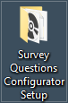

Run Database Script:

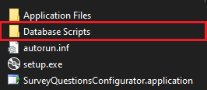



**1.2 Setup the application**

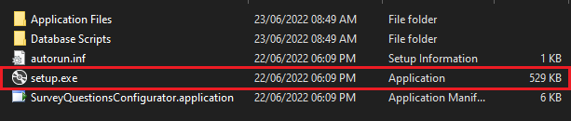

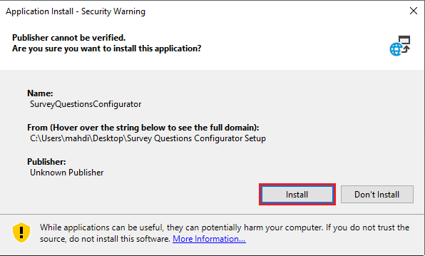

**1.3 Connection Settings**

The application will automatically open.

If not, it can be found in the start menu.

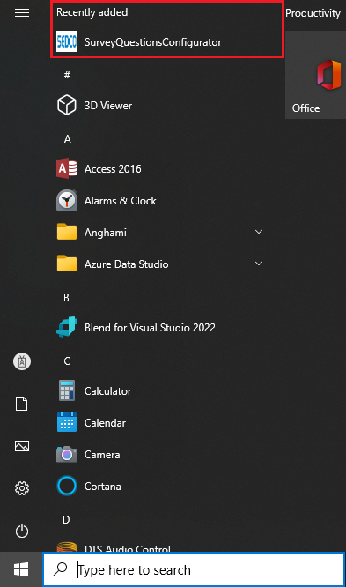

Check connection settings if needed.

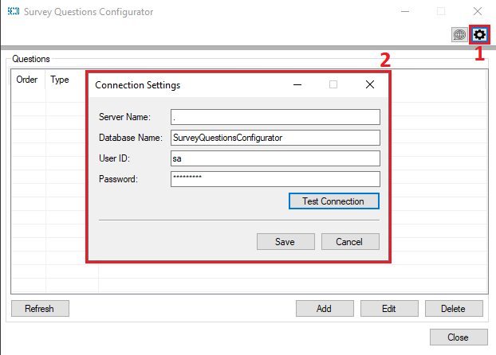

**1.4 Uninstallation**

Search for control panel

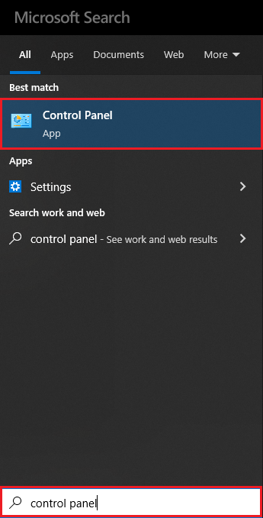

Search for and open programs and features.

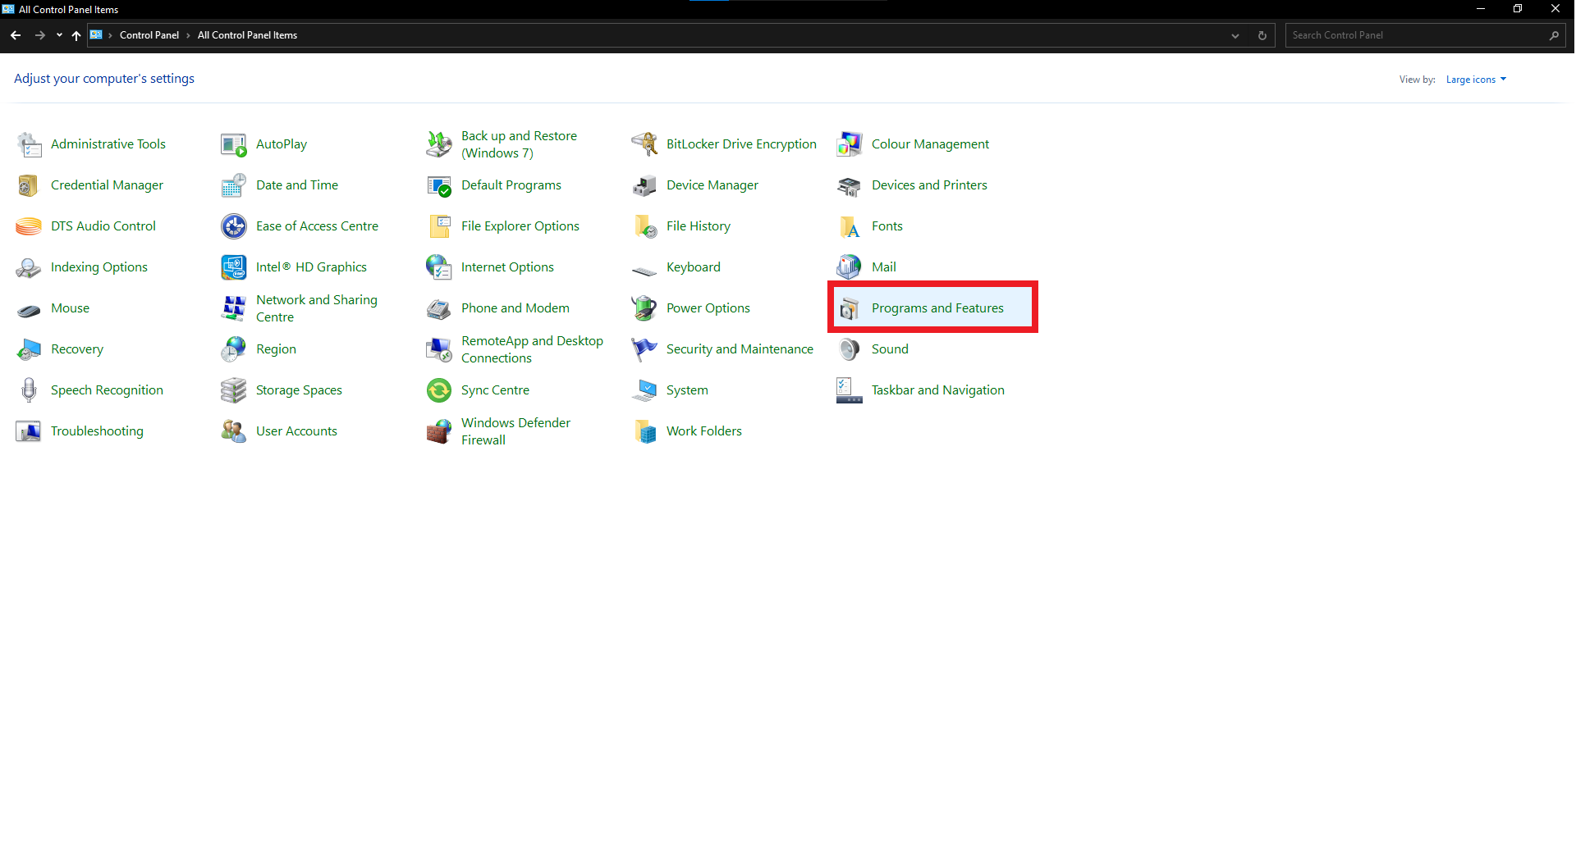

Uninstall the application

